Part 2
The Crime Scene
In a quiet camping area known as Moomaw Lake, four complete human skeletons were found in the mud when the lake began to dry during a drought. Detectives checked the missing person’s reports for people in the area and found that five people had disappeared from the area over the last 10 years.
Oddly, the skeletons were almost completely intact due to being somewhat preserved in the clay at the bottom of the lake.
(Note This is ficticious!)
Moomaw lake
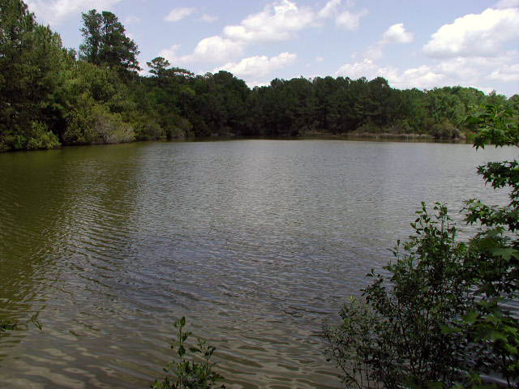

Photos of the Remains found:
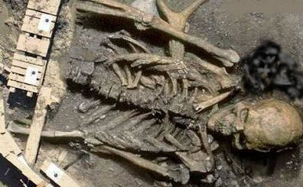
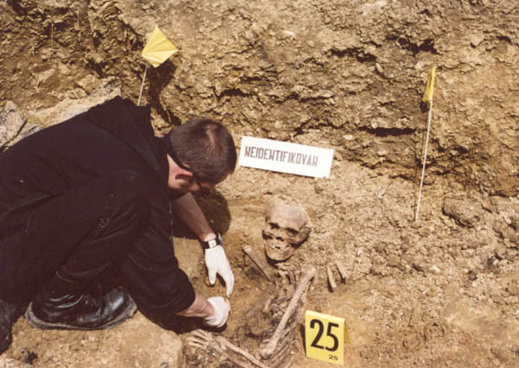
Now you will need to see your teacher to get your “bones” for reconstruction.
Instructions for “bone reconstruction”
- Cut out the bones, then use tape or glue to paste them on your white sheet of paper.
- Next you will need to label each bone
- Next you will need to determine the identity of the bones based on age and height
- Determine the gender of your subject by looking at shapes of specific bones
- Use the following formula to determine the height of your subject
Your “paper” skeleton is not a real skeleton, but assume that 1cm on your paper skeleton =8.6cm on the real skeleton.
Male (real) is 2.32 x length of the femur in cm +65.53+/- 3.94
Female (real) is 2.47 x length of the femur in cm +54.10 +/- 3.72

You may want to utilize the feet to cm height conversion on my webpage
- On your reconstructed skeleton, include information about the gender and height of the skeleton and point our your reasoning for your claims (include formulas or arrows to bones, etc.)
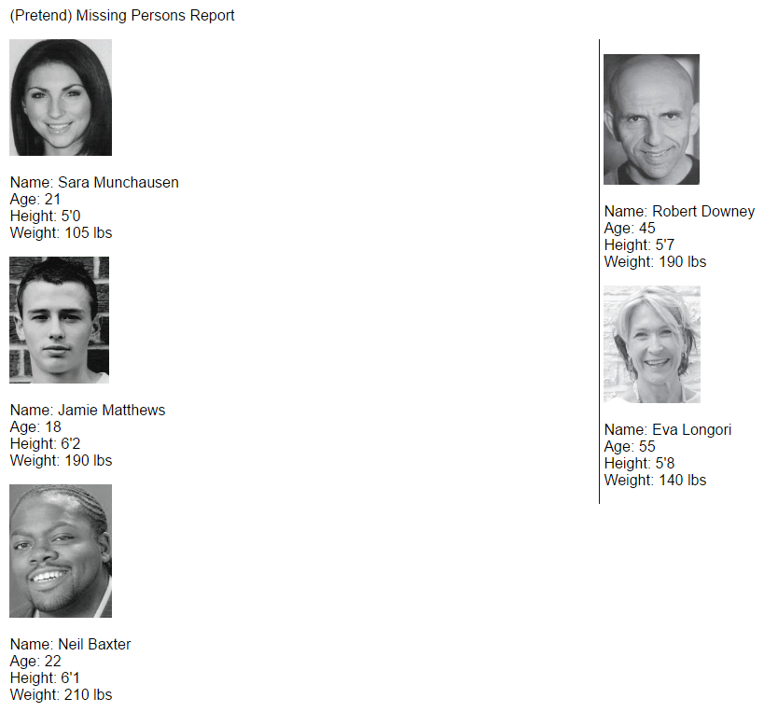

Now you will need to view the skulls to determine age:
Each of the skulls were examined in detail. See if you can determine the age (either over 35 or under 35) by the sagittal sutures. Remember that sutures close fully by the age of 35.

Skeleton 1:
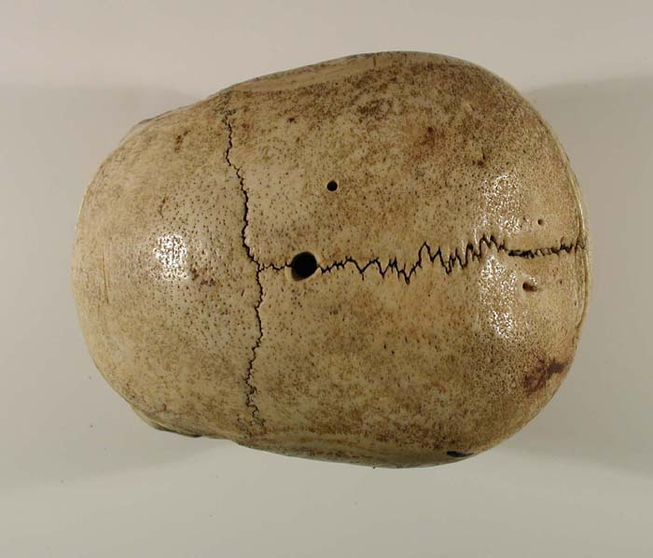
Skeleton 2:
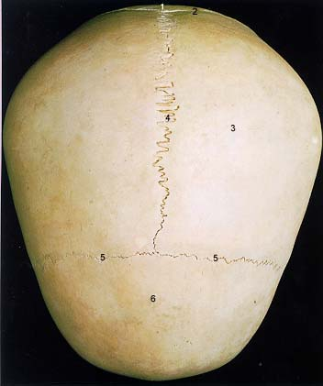
Skeleton 3:
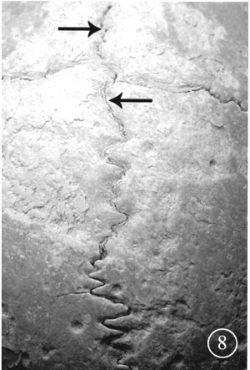
Skeleton 4:
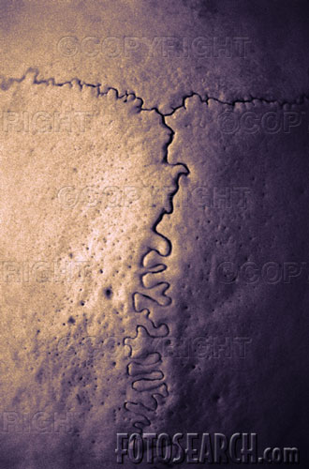
Facial Reconstruction:
For this part of your investigation, you have sent your skull to the forensic artist who has made a clay sculpture to estimate what your skeleton looked like. Below are the results:
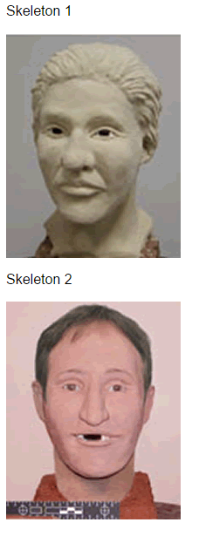
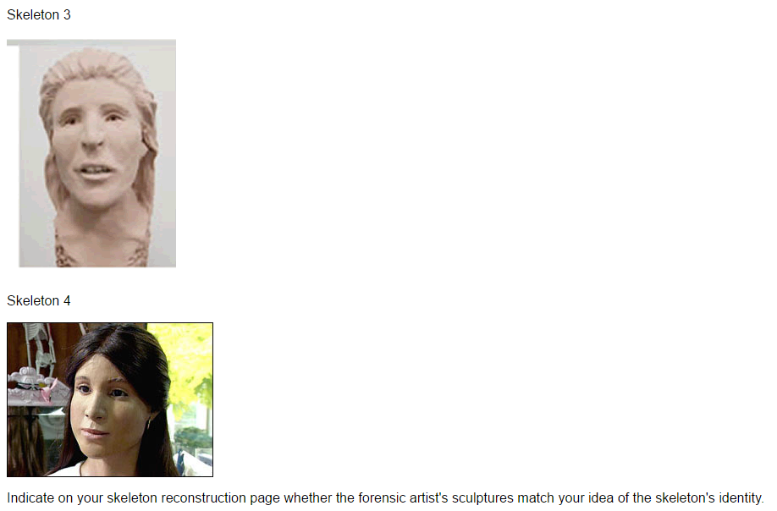

Now make sure that you turn in ALL of your work! You will need to ensure that each part is complete to get full credit.

